**QUESTIFY FYP PORTAL**

FYP System Diagrams (BSCS)

By

|  |  |  |  |  |
| --- | --- | --- | --- | --- |
| S# | **Name** | **Registration #/Roll #/Section** | **Mobile #** | **E-Mail** |
| 1. | ATEEQ UR REHMAN | Fa-2021/BSCS/197-E | +92 312 5053926 | ateeq786316@gmail.com |
| 2. | MUHAMMAD TALHA | Fa-2021/BSCS/167-E | +92 313 7839889 | talhamughal2599@gmail.com |

**Supervised by:**

Ms.Rabia Khan

**(Signature)**



Department of Computer Science Lahore Garrison

University Lahore

# **Table of Figures**

Figure 1:Use case diagram 3

Figure 2: I-Architectural Diagram 4

Figure 3:II-Architectural Diagram 4

Figure 4:Components Diagram 5

Figure 5:Level-0 DFD diagram 6

Figure 6:Level-1 DFD diagram 7

Figure 7:Class Diagram 8

Figure 8:Entities relations Diagram 9

Figure 9:Sequence Diagram 10

Figure 10:I-Activity Diagram 12

Figure 11:II-Activity Diagram 13

Figure 12:State Diagram 15

Figure 13:Landing page 17

Figure 14:Overall login 18

Figure 15:Contact us 19

Figure 16:About US 20

Figure 17:Student Login 21

Figure 18:Student Dashboard 22

Figure 19:Student submit proposal 23

Figure 20:Student Chatbot 24

# **SYSTEM DIAGRAMS**

# **Use case Diagram**

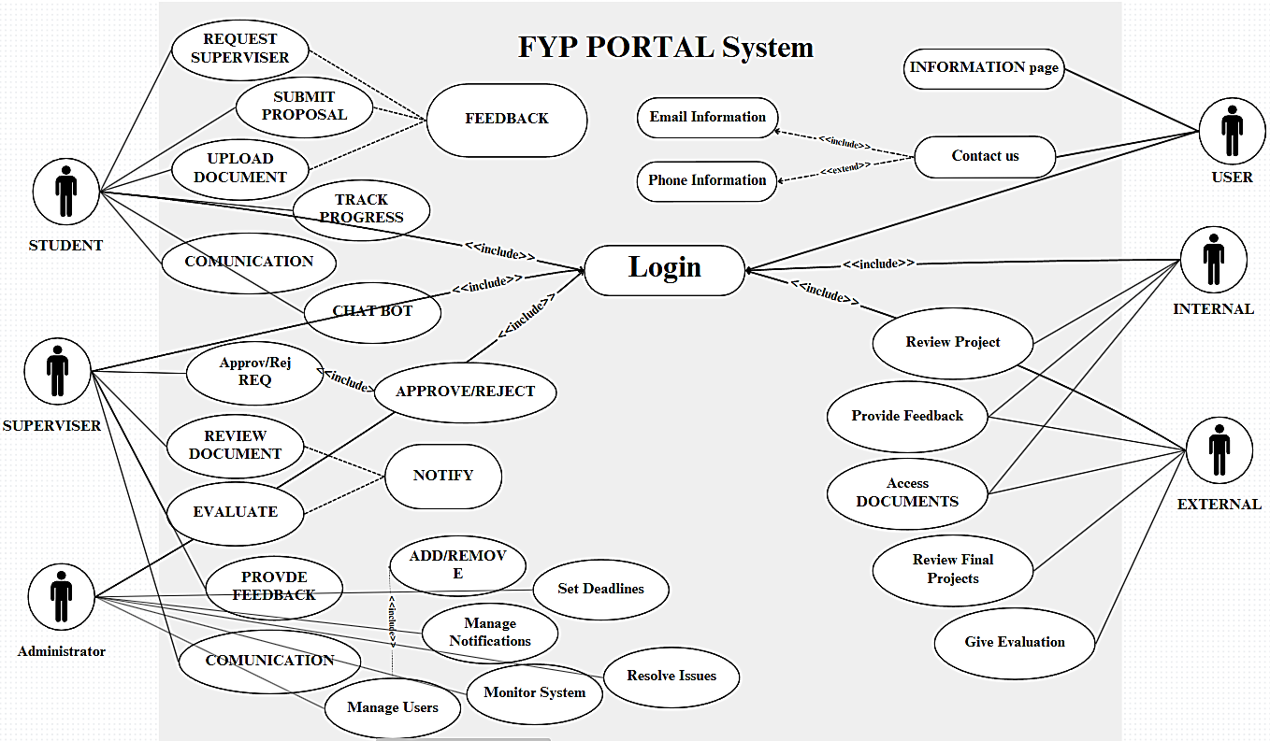

Figure 1:Use case diagram

The Use Case Diagram for the Final Year Project (FYP) Portal is picture of how every user like students, supervisors, admin, and evaluators will interact with the system. Student are the main users, they will perform task like submitting project proposal, uploading documents, tracking their progress, and communicating with supervisors. Supervisors will review proposal, give feedback, approving documents, creating meeting with student to guide them. Admin will make sure the system works properly, managing the account of users, send crucial mails, setting deadlines for the submissions, and fixing overall issues. Evaluator will access the project’s documents, evaluating and providing feedback on them and at end grading them. The whole system starts after simple login, showing options that make managing FYP’s easier and efficient.

# **Architectural Diagram**

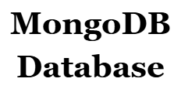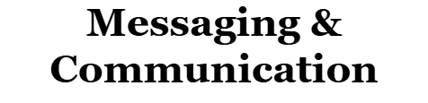

Figure 2: I-Architectural Diagram

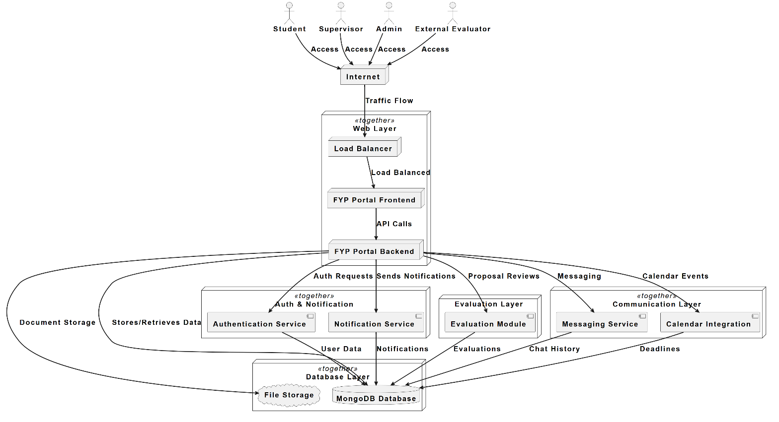

Figure 3:II-Architectural Diagram

The architectural diagram provides a clear understanding of Final year Project (FYP) management system, how it works, a clear view how main four users’ students, supervisors, admin and evaluators interact with each other within system. Student, supervisor and admin will use the main FYP portal, whereas the evaluators will only access evaluation tab. This will help in smooth running of system; a load balancer distributes the user’s traffic over the server. The web layer has frontend, which take care of user interaction, and the backend, it will work on logic, API requests, connection of important services. The backend also links with aauthentication service for users’ verification for accessing the portal, and notification services to share all new important messages. All data is stored in MongoDB database, whereas uploaded files are managed separately. The design shows the main features like document storage, reviews, messaging, feedback, calendar integration, map integration, and evaluation workflow, providing a complete scenario of how the system work in FYP management while making the experience smooth, efficient and scalable performance.

# **Component’s Diagram**

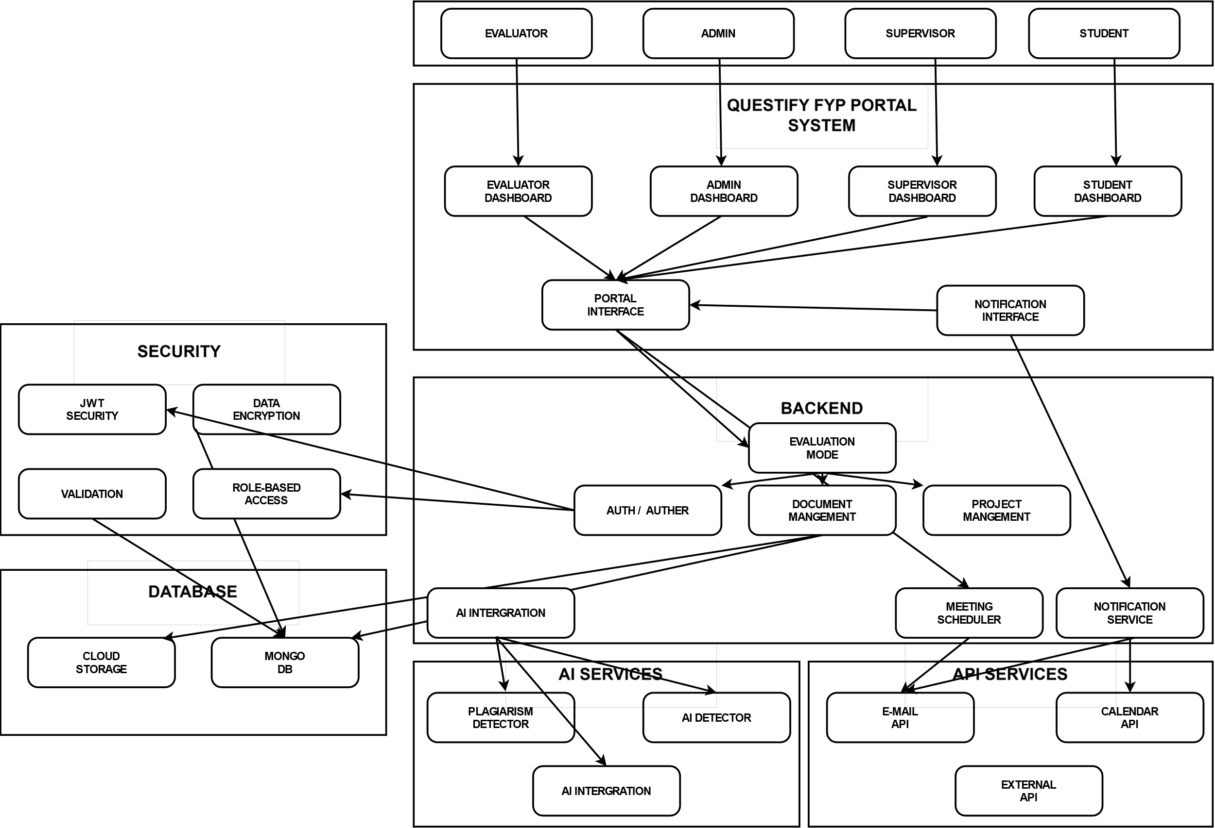

Figure 4:Components Diagram

The component diagram of Questify FYP portal shows the clear parts of the system that how it is structured, visualizing main components, how they connect and work together. All users have their personal dashboard according to their roles. All users connect with a portal interface, which manages user interaction, navigation and all frontend experience. Whereas in backend, the system have two parts like authentication and authorization, Document management, project management, evaluation, meeting arrangement, and notification service, all work in backend to make a smooth and functional system. Security is core have feature, JWT authentication, data encryption, validation, and role-based access control. Data is stored and managed by MongoDB and cloud storage for documents. The system has AI services for plagiarism and AI detection, more services via API requests, including email API, calendar API and other third-party integrations. The diagram highlights the modules, secure and scalable nature of the Questify FYP portal.

# **Data Flow Diagram (DFD)**

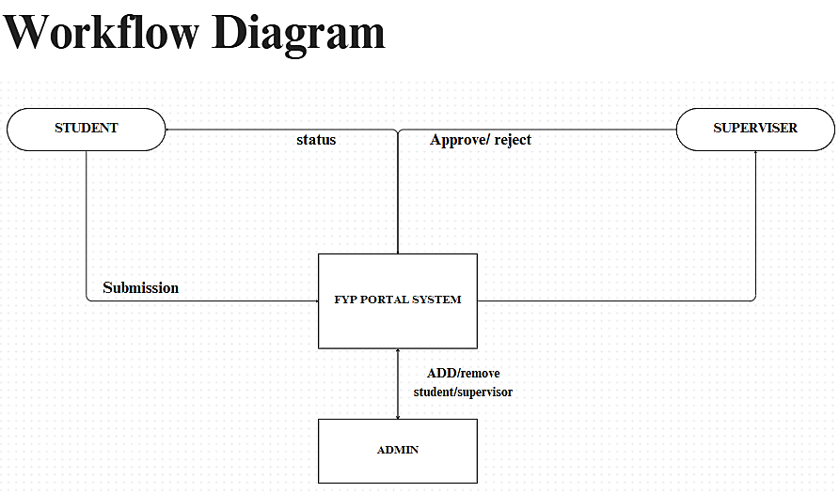

Figure 5:Level-0 DFD diagram

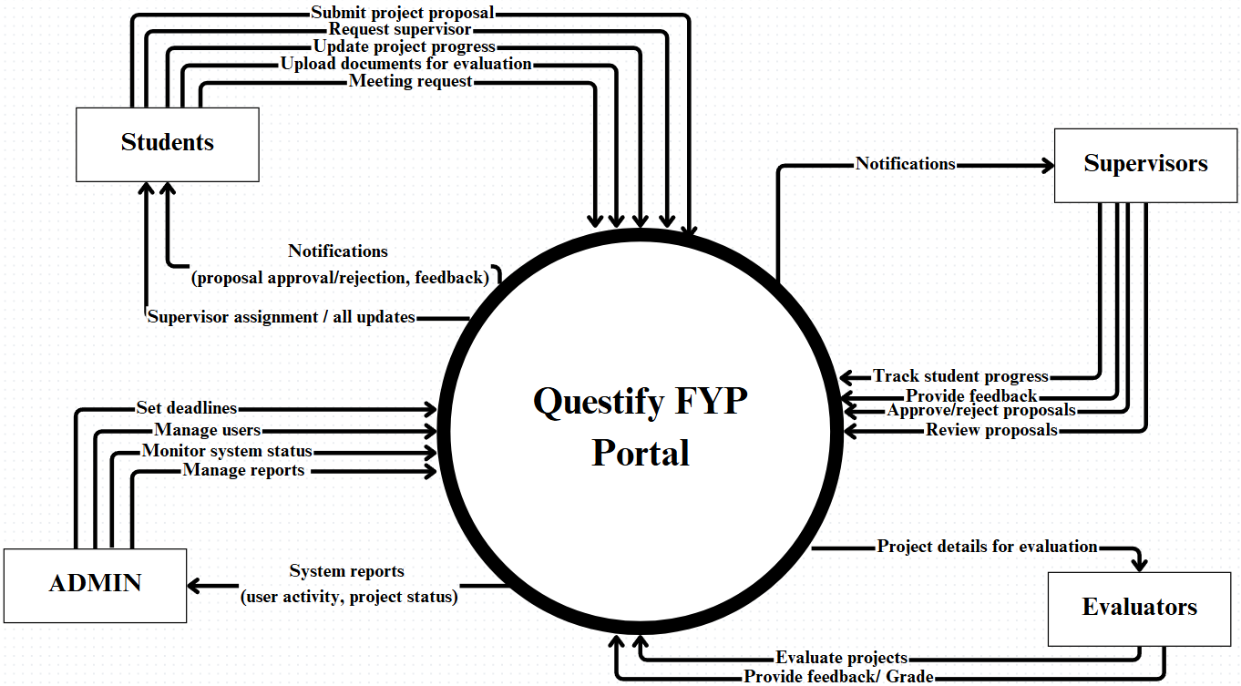

Figure 6:Level-1 DFD diagram

The Data flow diagram (DFD) show direct flow of data, how the data move with in system, how the users interact with it. Student start by submitting project proposal, requesting supervisor, tracking progress, uploading documents, meeting. Supervisor receive notifications for request, proposal review, then provide feedback, and either approve or reject. Admin manage overall system’s things like user accounts, setting deadlines, assigning supervisor, check system. Evaluators have limited work they only come when evaluation needed reviewing submitted work, providing feedback on that work, assigning grade. The Questify FYP portal is central hub, make sure smooth flow between users. This DFD clear tells how the system’s process connect, and how data is interchange between users and system.

# **Class Diagram**

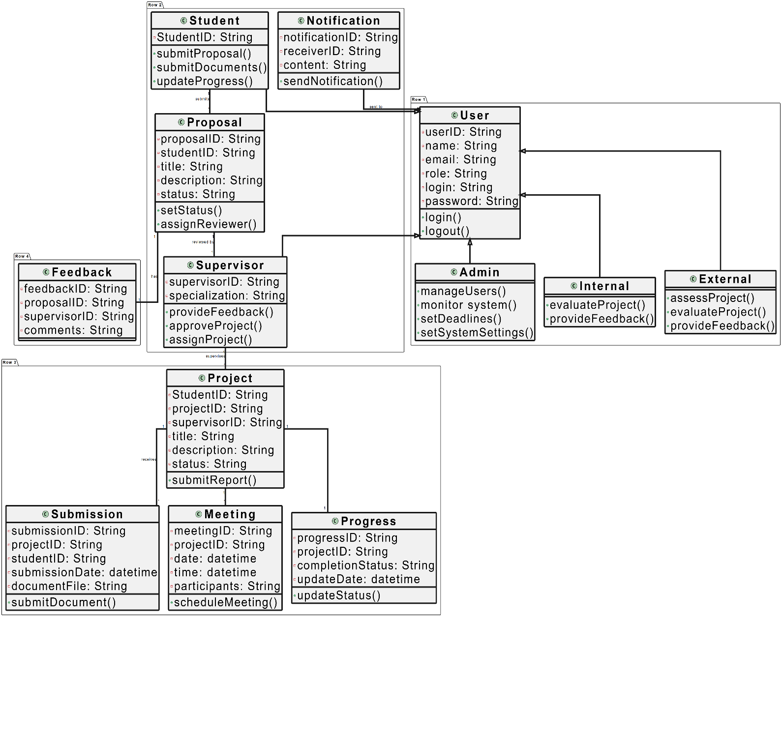

Figure 7:Class Diagram

The class diagram for Questify FYP portal how the system is built and how FYP process at Lahore Garrison University. It has classes which have key details like user ID, name, email, role and login credentials. From this start, specific roles such as students, supervisor, Admin and evaluator each have their own functions. The diagram show the classes interaction of users with each other, it highlight overall how users connect in a organized way for managing FYP’s efficiently.

# **ER Diagram**

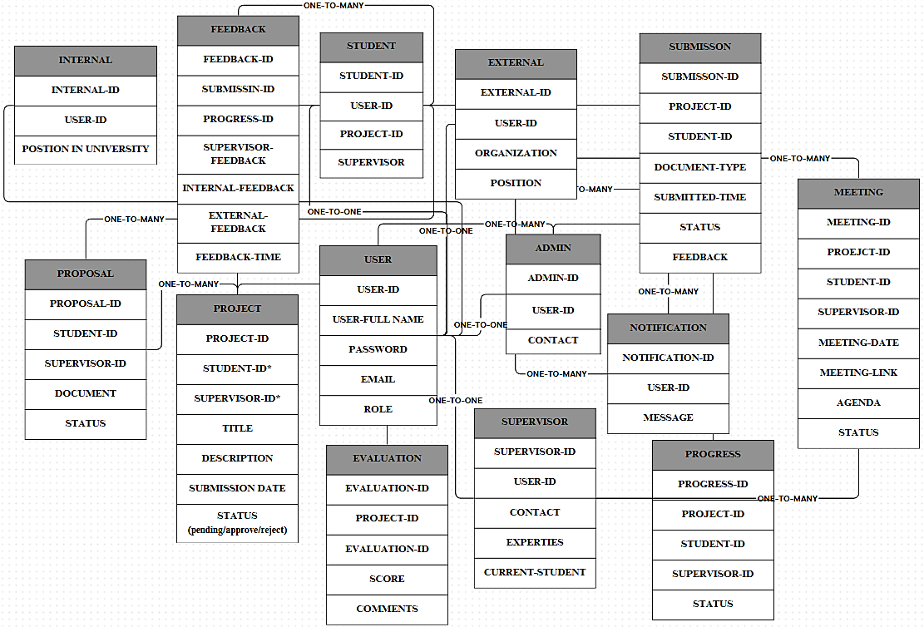

Figure 8:Entities relations Diagram

The structure of the Questify FYP portal telling how the entities of project interact with each other and what are the relation between users.

# **Sequences Diagram**

The image depicts various sequence diagrams for the Final Year Project (FYP) System, illustrating the interactions between different actors (Student, Supervisor, Admin, Internal, External) and the system itself.

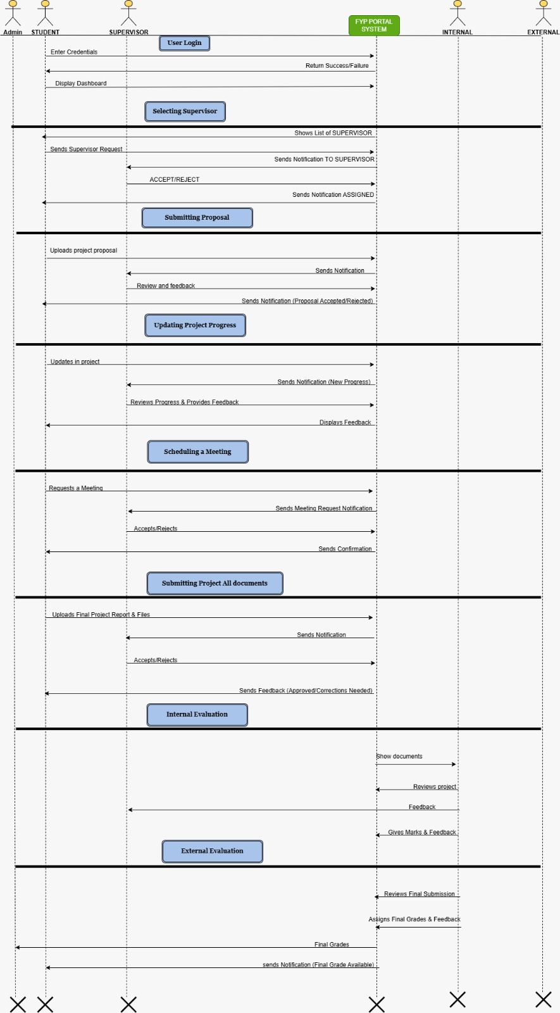

Figure 9:Sequence Diagram

The diagram shows the student journey throughout the Questify FYP portal, start with login that allow to access portal according to their role. As student first project proposal, then selecting supervisor, send request, when supervisor assigned, review proposal then approve or return with feedback, Further student progress and update project, constantly get feedback from supervisor. Creating meeting for communication, with request and confirmation handle directly. After document submission face the project enter in evaluation process, evaluator access final project and provide grades and feedback on project, that complete the FYP journey.

# **Activity Diagram**

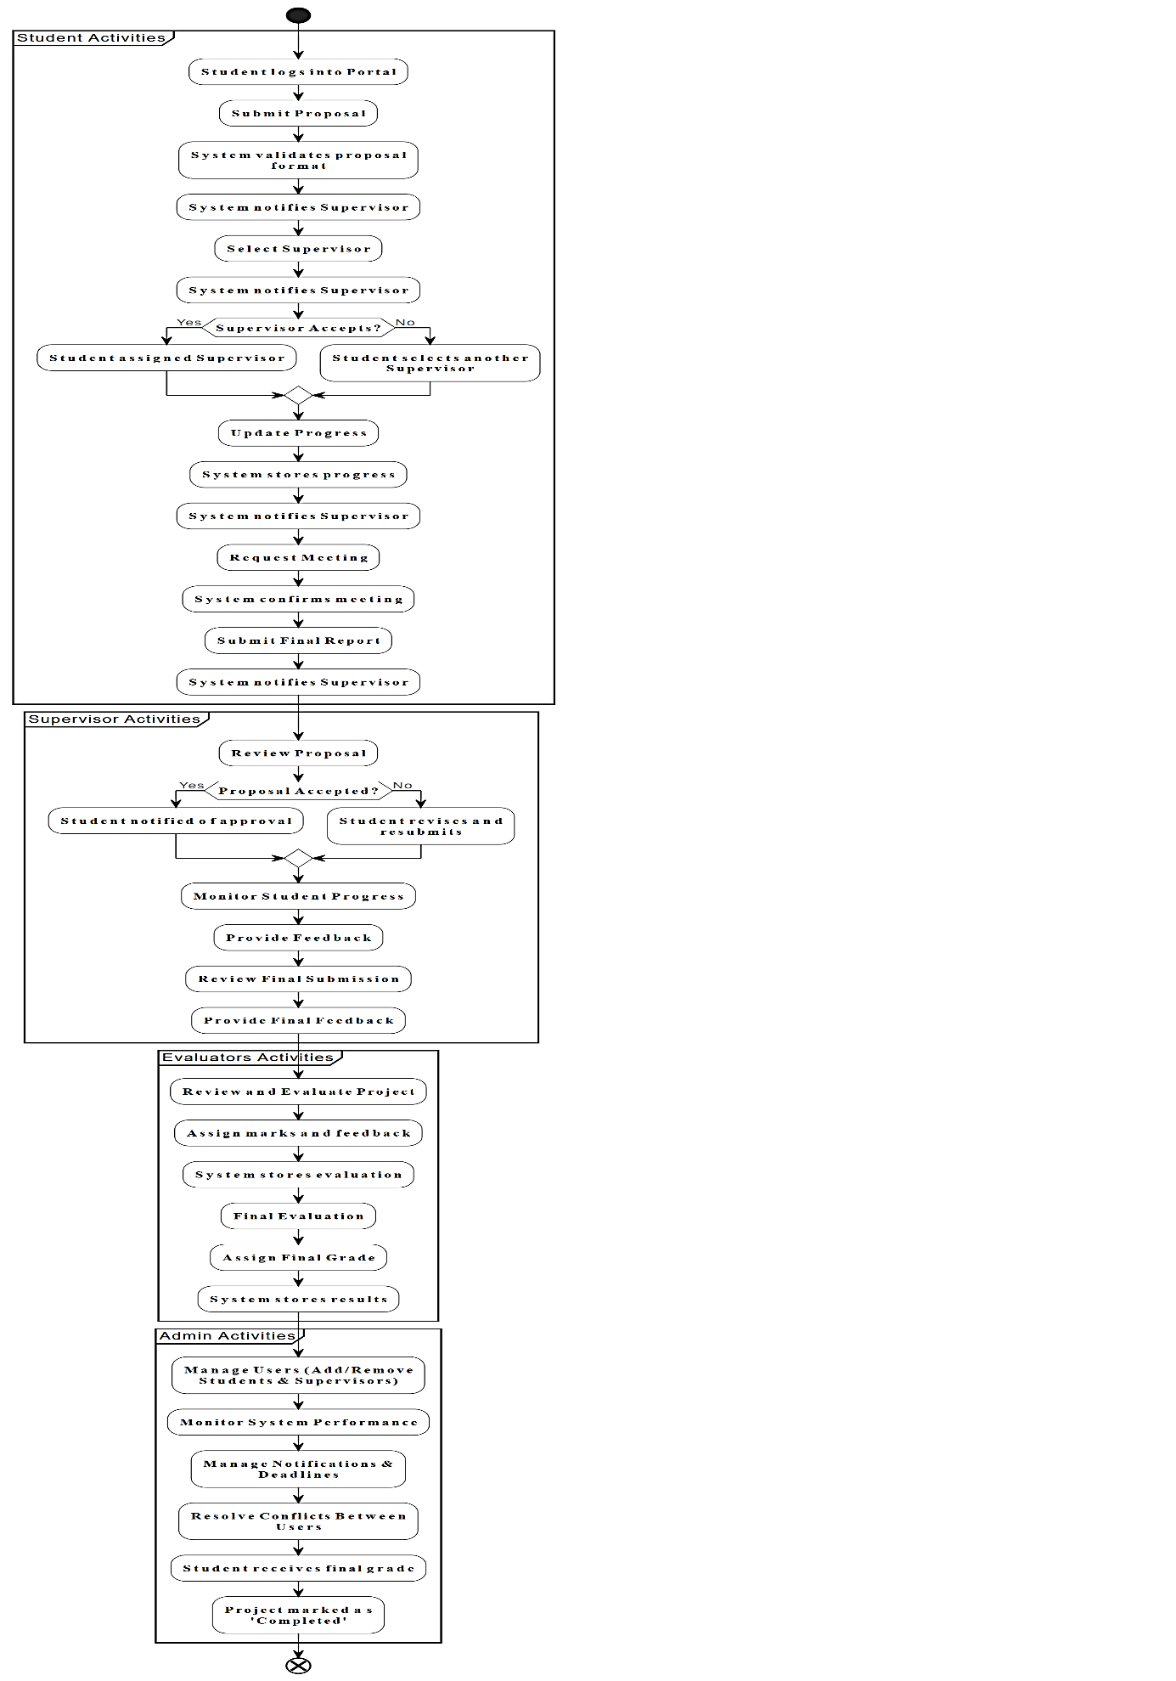

Figure 10:I-Activity Diagram

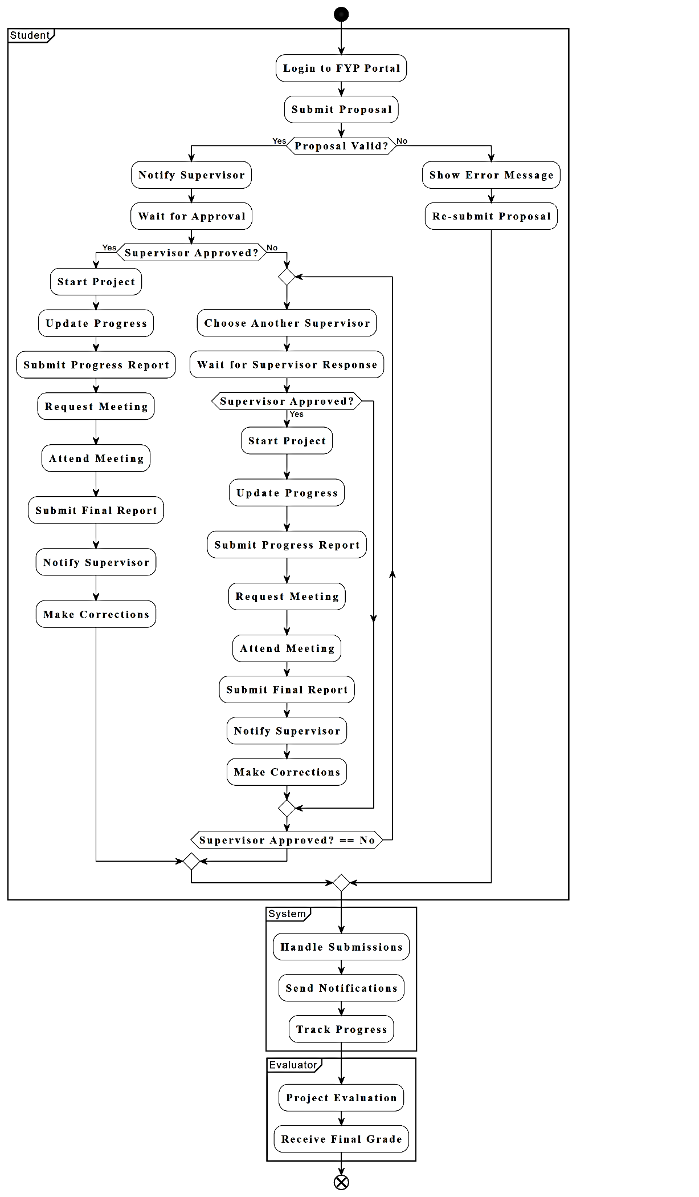

Figure 11:II-Activity Diagram

This activity diagram shows the interaction of all users with the Questify FYP portal system, starting from the simple login by the student, follow up by submitting proposal, system check validation, select supervisor, system notify supervisor about proposal, then accept or again for updating after feedback, update progress, system store every changing and progress in project, meeting requests, notifications, when almost near to completion of project, submit final report, get supervisor review, then evaluation, where evaluators access document and review project then provide feedback and grade them. At admin level he manage users, deadlines, notifications, and resolve conflicts and finally generate grade, and the system marks the project as completed

# **State Diagram**

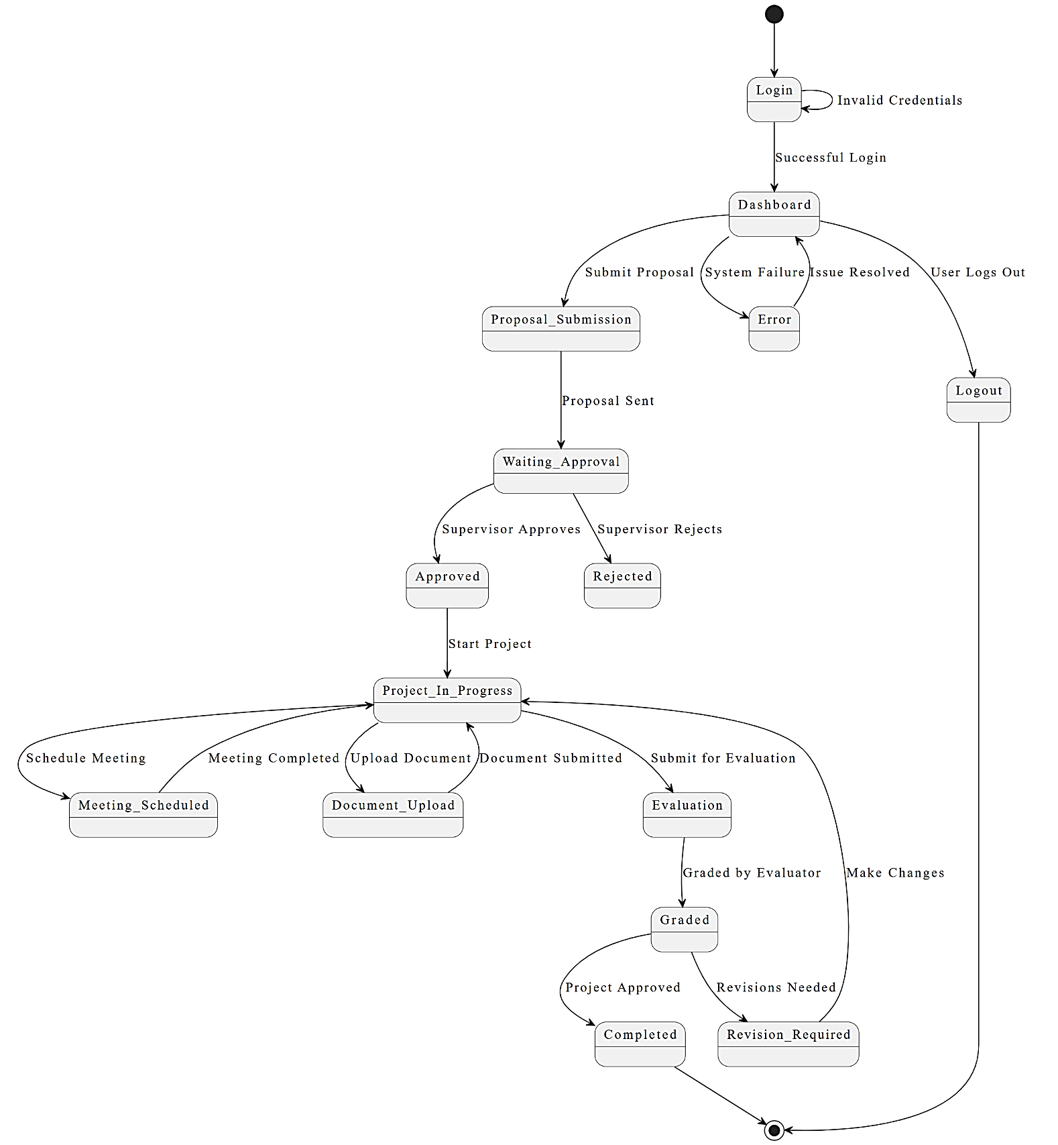

Figure 12:State Diagram

The state diagram of Questify FYP portal refers to the user interaction with system from login to project completion. Users login, submit proposal, and move one by one through states like waiting for review, approval, feedback, project in progress and evaluation. Successful projects reach the completed state.

# **PROTOTYPE**

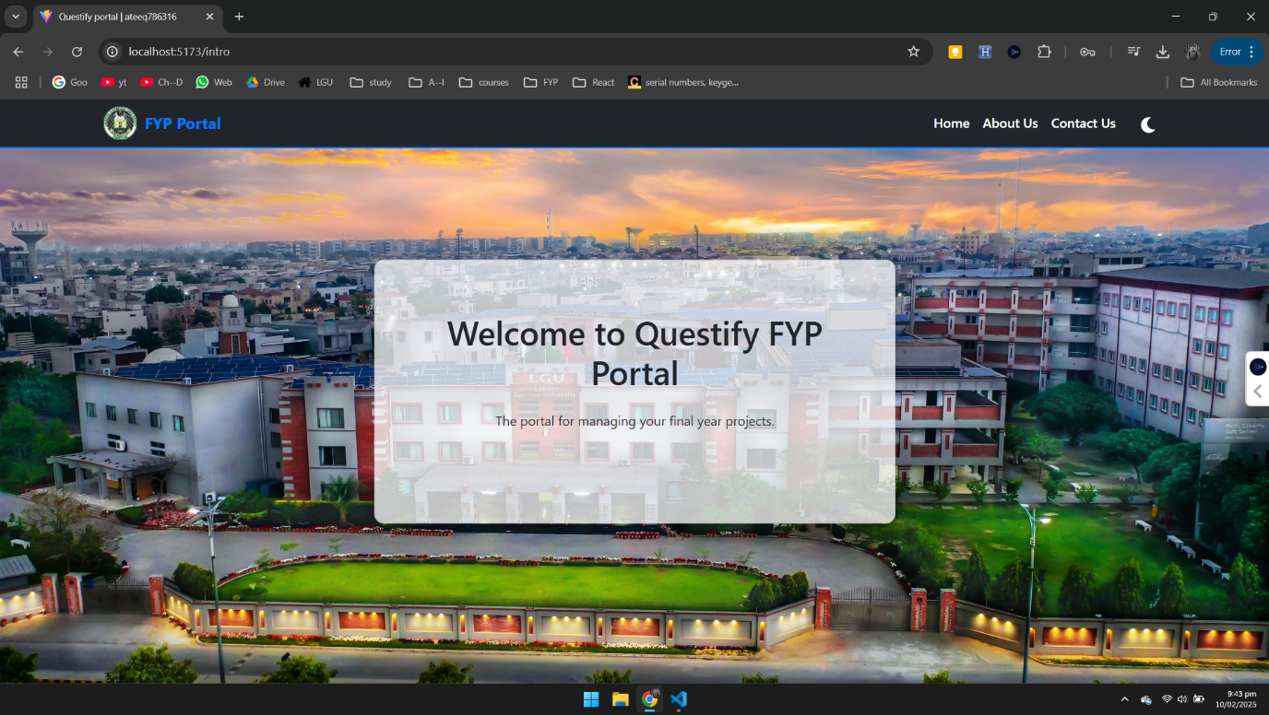

Figure 13:Landing page

**Description:**

The Questify FYP Portal homepage a simple, welcoming and starting page for managing final year projects. At the top, users are get greeted with a friendly welcome. A clean navigation bar at the top, making it easy to go to important sections like Home, About Us, and Contact Us. The university logo at top left, to make identification mark.

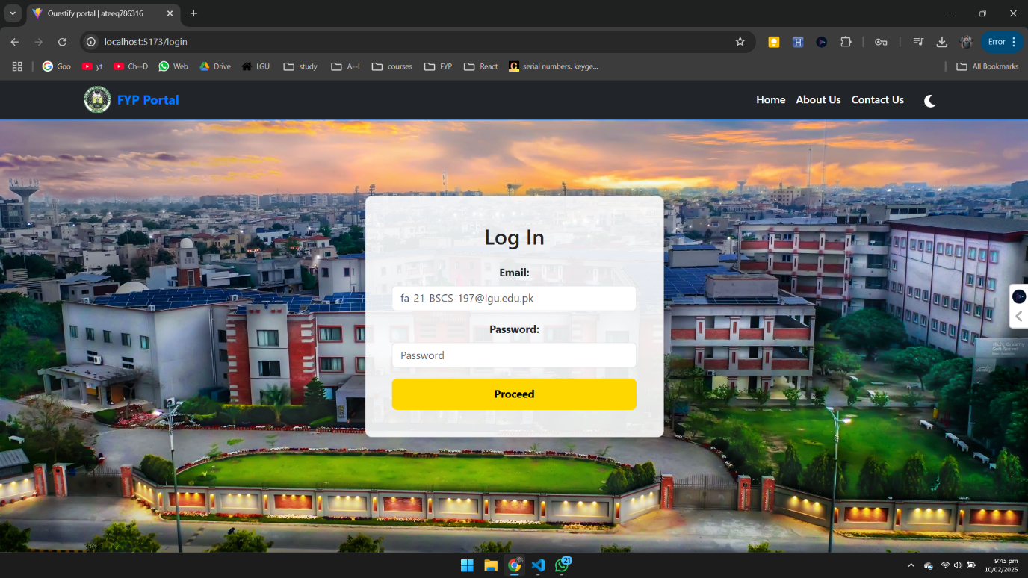

Figure 14:Overall login

**Description:**

The given page has functionalities to let the users login. When the credentials are entered, then by clicking proceed system will check the if credentials are correct or not. Then they will redirect their dashboard according to their role after authorization by the system.

Top of Form

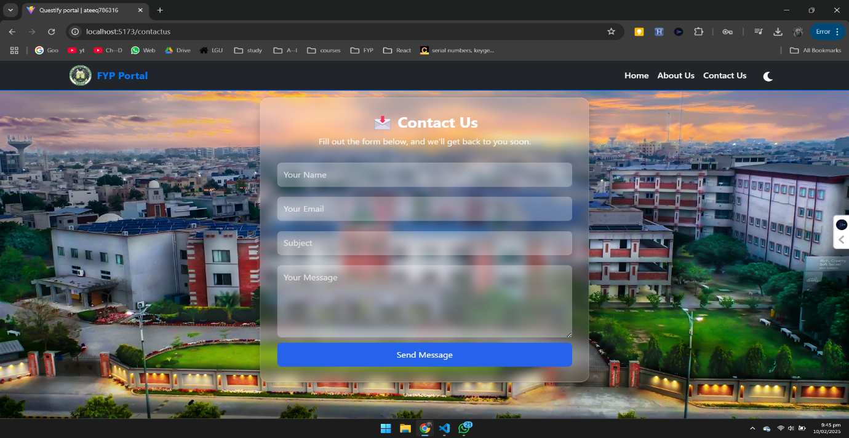

Figure 15:Contact us

**Description:**

The above Constact US page of the portal is visible to all without login so they ask their quries and get help from the coordinator. To get that they need to fill up the form along with there question and information.



Figure 16:About US

**Description:**

This page is background page of the portal, it has information about the university and it highlight the FYP works, this page has all background information about university and FYP system to educate if someone is visiting the system first time.

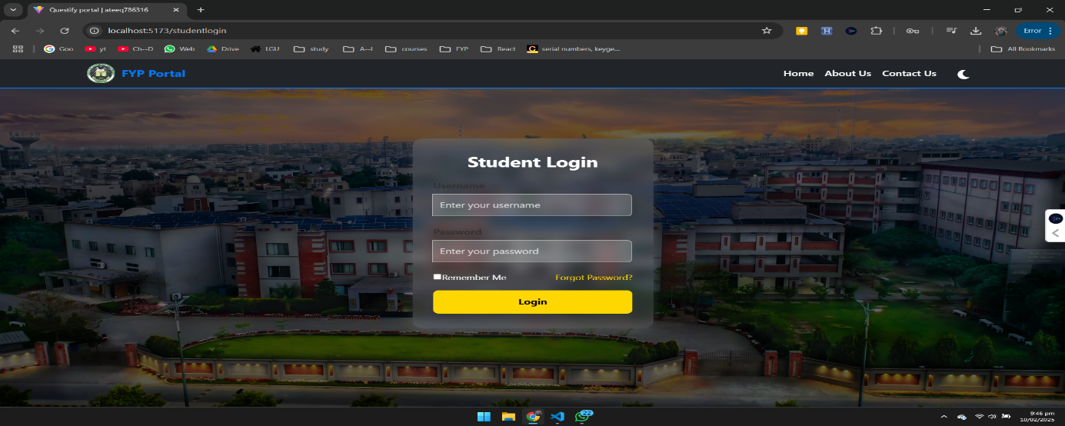

Figure 17:Student Login

**Description:**

The login page of the system for the student allow to access system with full security and privacy. Here, students enter their assigned username and password to log in. Clicking the "Login" button starts the authentication process, and once verified, students authorized to all the portal's features according to their role.

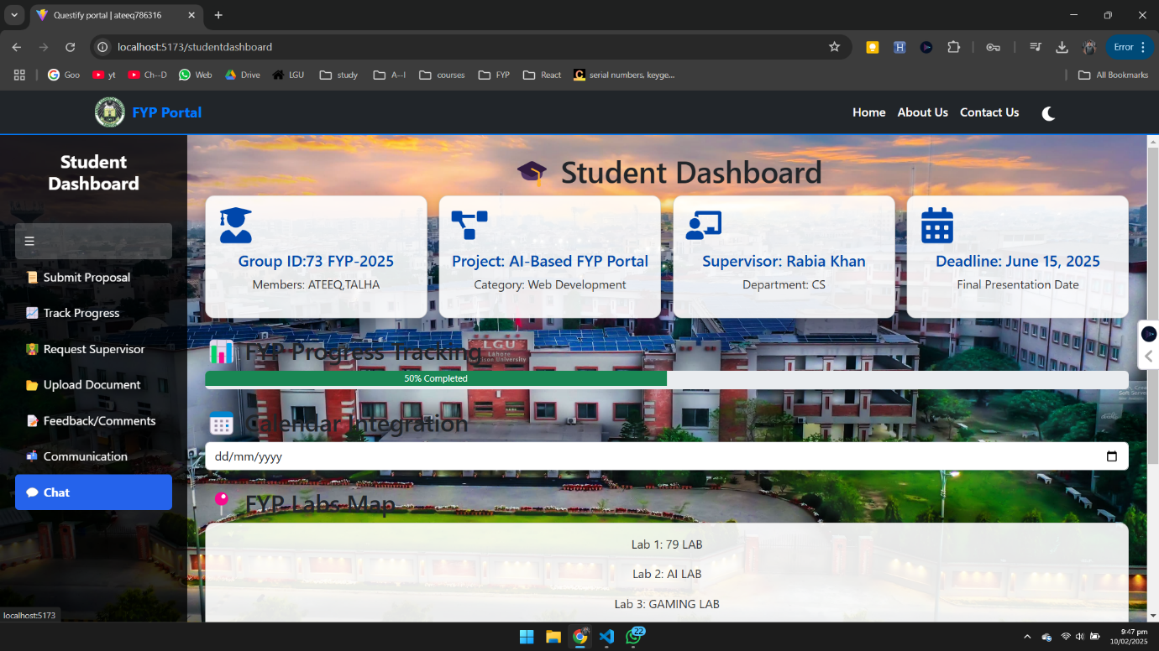

Figure 18:Student Dashboard

**Description:**

The Student Dashboard in the Questify FYP Portal is the main page where students can easily manage their final year projects. Once login, students see a clear dashboard which show details of their project, including the Group ID, Project Title, Supervisor’s name, and the project Deadline. A sidebar menu allow access to options like Submit Proposal, Track Progress, Request Supervisor, Upload Document, Feedback/Comments, and a Communication section that includes a Chat feature for direct interactions. There’s also Calendar, so students keep track of important dates and deadlines. A progress visually shows how’s the project progress. The "FYP-Labs Map" highlights available labs—Lab 1: 79 LAB, Lab 2: AI LAB, and Lab 3: GAMING LAB. Altogether, this dashboard is designed to help students stay organized, communicate effectively, and keep their projects on track.

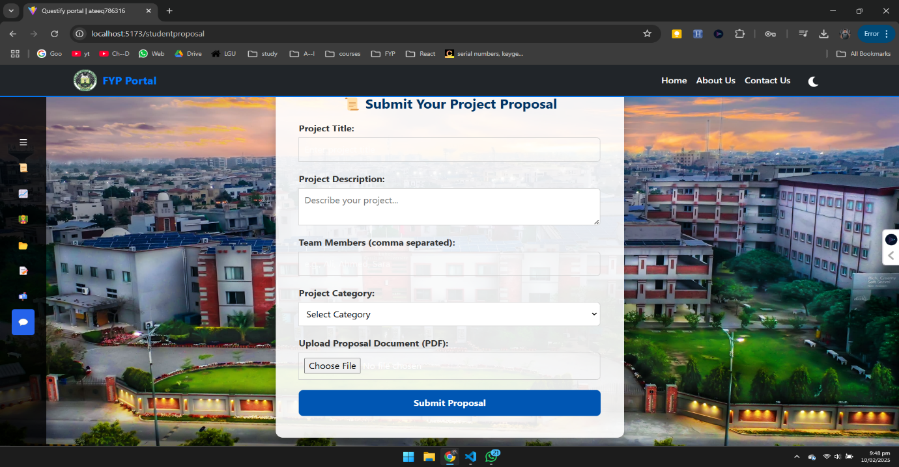

Figure 19:Student submit proposal

**Description:**

The "Submit Your Project Proposal" page on the Questify FYP Portal gives students a simple way to submit their FYP proposals. Students can fill in their Project Title, write a detailed Project Description, and list their Team Members by separating names with commas. They also select the appropriate Project Category from a dropdown menu to classify their project correctly. To complete the submission, students upload their proposal document in PDF format.   
when everything is entered, then by clicking Submit proposal button will upload proposal to the system. This page make sure that all needed information is entered about the project to work further on it.

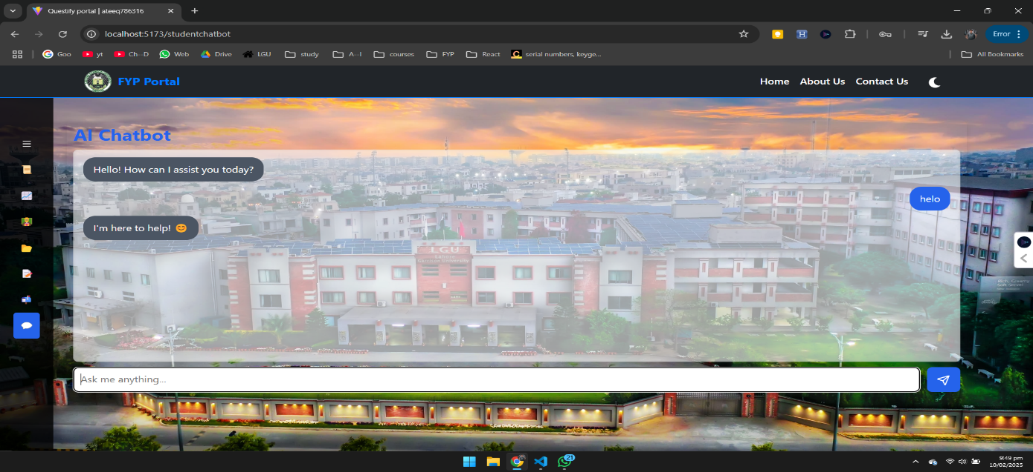

Figure 20:Student Chatbot

**Description:**

This page is given in student dashboard, it allows students to clear their short and little quires about their FYP’s, this bot will answer student by get help from different Ais like Chatgpt, Gemini, Lama, Deepseek, Blackbox, and some others. This feature will help students to clear their problem as soon as possible, direct question direct answer.